Monthly Coverage Dossier

May 2021

Future Generali India Life Insurance Company Limited

Sr. No | Overview of Activities | Key Publications
1 | Q& A  Overall insurance industry scenario_Niraj Kumar  Indian equity market so far & forecast for upcoming year_ Niraj Kumar  What are the top skill you will be looking for when recruit people s_ Pawan Chawla | - Dalal Street Investment Journal and Yahoo India  - Dalal Street Investment Journal and Yahoo India  - CISO
2 | Industry story- Quote  Have your cake and Eat it too [optional Riders]  _ Bikash Choudhary  How to choose riders in a guaranteed insurance plan_ Bikash Choudhary | - The Hindu Business Line [Print]  - The Hindu Business Line [Online]
4 | Press Release  FGILI launches Future Generali Money Back Plan | - Press Trust of India  - The Economic Times Wealth  - Dainik Bhaskar  - Janpath Samachar  - Gujarat Mirror  - Gujarat Samachar  - Nav Gujarat  - Samay Express  - Suvarna Bhoomi  - Zalawad Samachar  - Dinakathir  - Dinakural  - Tamil Sundar  - Andhra Prabha  - Mana Telangana  - Vaartha  - Praja Sakti  - Velugu  - Jansandesh  - Rashtriya Swaroop  - Spast Awaaz  - PTI [Yahoo India]  - Telugu Web Dunia  - Echo if India  - Vishwamitra
Index
Sr. No | Publication | Headline | Date | Coverage appeared
Interview
1 | Dalal Street Investment Journal | In interaction with Niraj Kumar, Chief Investment Officer, Future Generali India Life Insurance Co. Ltd | 20th May 2021 | Online
2 | Yahoo Finance | In interaction with Niraj Kumar, Chief Investment Officer, Future Generali India Life Insurance Co. Ltd | 20th May 2021 | Online
3 | Dalal Street Investment Journal | Indian equity market so far & forecast for upcoming year | 24th May 2021 | Online
4 | Yahoo Finance | Indian equity market so far & forecast for upcoming year | 24th May 2021 | Online
5 | CISO Magazine | As a CISO what are the top skills you would be looking for when you recruit people? | 19th May 2021 | Print
Industry Story
6 | The Hindu Business Line | Have your cake and eat it too | 30th May 2021 | Print
7 | The Hindu Business Line | How to choose riders in a guaranteed insurance plan | 30th May 2021 | Online
Press Release -FGILI Launches Cash Back Plan
8 | PTI [Yahoo Finance ] | Future Generali India Life Insurance launches Money back super plan | 24th May 2021 | Online
9 | Telugu Web Dunia | Future Generali India Life Insurance launches Money back super plan | 26th May 2021 | Online
10 | The Economic Times | Future Generali India Life Insurance launches Money back super plan | 24th May 2021 | Print
11 | Janpath Samachar | Future Generali India Life Insurance launches Money back super plan | 21st May 2021 | Print
12 | Gujarat Mirror | Future Generali India Life Insurance launches Money back super plan | 26th May 2021 | Print
13 | Gujarat Samachar | Future Generali India Life Insurance launches Money back super plan | 26th May 2021 | Print
14 | Samay Express | Future Generali India Life Insurance launches Money back super plan | 26th May 2021 | Print
15 | Nav Gujarat | Future Generali India Life Insurance launches Money back super plan | 27th May 2021 | Print
16 | Suvarna Bhoomi | Future Generali India Life Insurance launches Money back super plan | 26th May 2021 | Print
17 | Zalawad Samachar | Future Generali India Life Insurance launches Money back super plan | 26th May 2021 | Print
18 | Nav Gujarat Samay | Future Generali India Life Insurance launches Money back super plan | 27th May 2021 | Print
19 | Dina kathir | Future Generali India Life Insurance launches Money back super plan | 27th May 2021 | Print
20 | Dinakural | Future Generali India Life Insurance launches Money back super plan | 27th May 2021 | Print
21 | Tamil sudar | Future Generali India Life Insurance launches Money back super plan | 27th May 2021 | Print
22 | Andhra Prabha | Future Generali India Life Insurance launches Money back super plan | 27th May 2021 | Print
23 | Mana Telangana | Future Generali India Life Insurance launches Money back super plan | 27th May 2021 | Print
24 | Praja Sakti | Future Generali India Life Insurance launches Money back super plan | 27th May 2021 | Print
25 | Vaartha | Future Generali India Life Insurance launches Money back super plan | 27th May 2021 | Print
26 | Velugu | Future Generali India Life Insurance launches Money back super plan | 27th May 2021 | Print
27 | Visalaandhra | Future Generali India Life Insurance launches Money back super plan | 29th May 2021 | Print
28 | Jansandesh Times | Future Generali India Life Insurance launches Money back super plan | 28th May 2021 | Print
29 | Rashtriya Swaroop | Future Generali India Life Insurance launches Money back super plan | 29th May 2021 | Print
30 | Spast Awaz | Future Generali India Life Insurance launches Money back super plan | 29th May 2021 | Print
31 | Echo of India | Future Generali India Life Insurance launches Money back super plan | 29th May 2021 | Print
32 | Dainik Bhaskar | Future Generali India Life Insurance launches Money back super plan | 29th May 2021 | Print
33 | Vishwamitra | Future Generali India Life Insurance launches Money back super plan | 29th May 2021 | Print

Interview

Date | 20 May, 2021
Publication | Dalal Street Investment Journal
Headline | In interaction with Niraj Kumar, Chief Investment Officer, Future Generali India Life Insurance Co. Ltd
Link | https://www.dsij.in/DSIJArticleDetail/ArtMID/10163/ArticleID/18417/In-interaction-with-Niraj-Kumar-Chief-Investment-Officer-Future-Generali-India-Life-Insurance-Co-Ltd
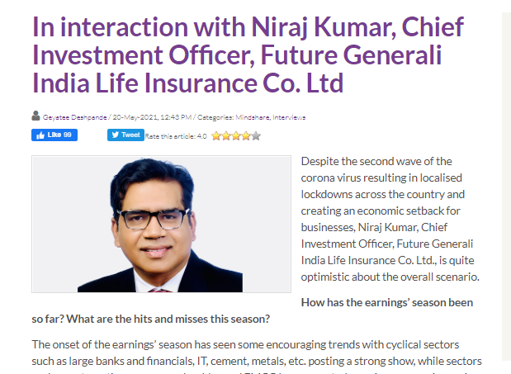
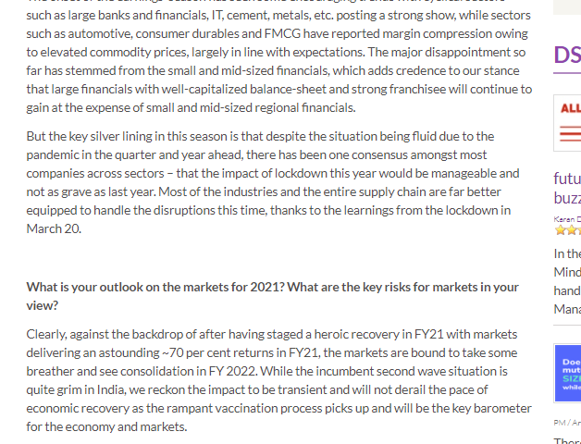
Date | 20 May, 2021
Publication | Yahoo Finance
Headline | In interaction with Niraj Kumar, Chief Investment Officer, Future Generali India Life Insurance Co. Ltd
Link | https://in.finance.yahoo.com/news/interaction-niraj-kumar-chief-investment-071300510.html

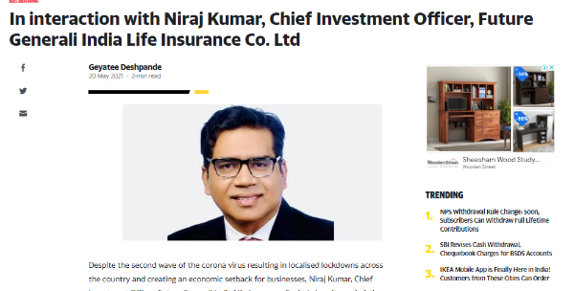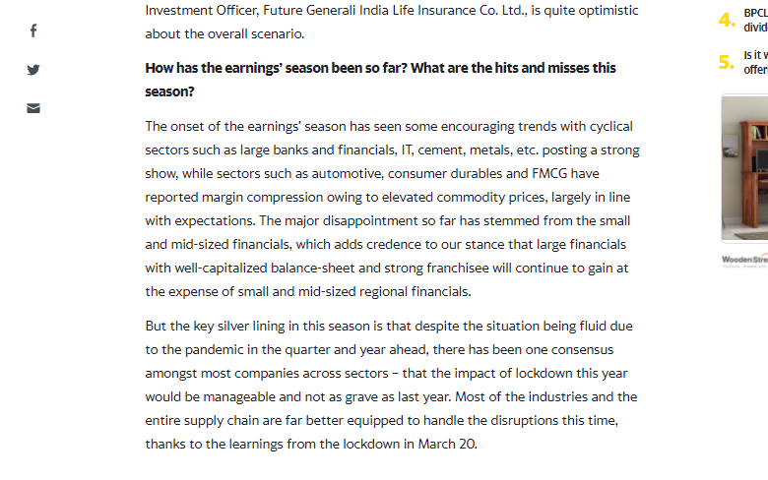

Date | 24 May, 2021
Publication | Dalal Street Investment Journal
Headline | Indian equity market so far & forecast for upcoming year
Link | https://www.dsij.in/DSIJArticleDetail/ArtMID/10163/ArticleID/18454/Indian-equity-market-so-far-forecast-for-upcoming-year

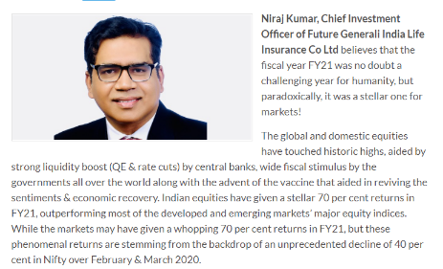
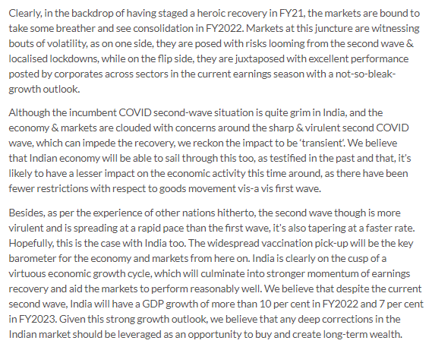

Date | 24 May, 2021
Publication | Yahoo Finance
Headline | Indian equity market so far & forecast for upcoming year
Link | https://in.finance.yahoo.com/news/indian-equity-market-far-forecast-060600312.html

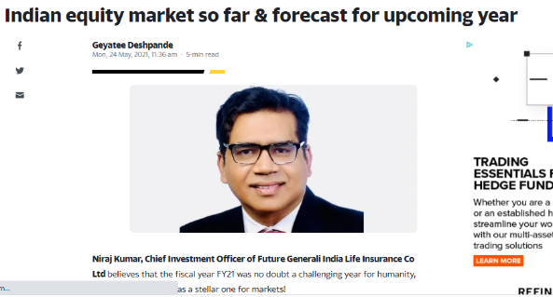

Published Date: | 19th May 2021 | Publication: | CISO Magazine – All India
Journalist: |  | Page No: | 52



Industry Story

Published Date: | 30th May 2021 | Publication: | The Hindu Business Line – | Ahmedabad | Bangalore | Mumbai | Chennai | Hyderabad| Kochi | Delhi | Kolkata |
Journalist: | Bhavadharani KS | Page No: | 9

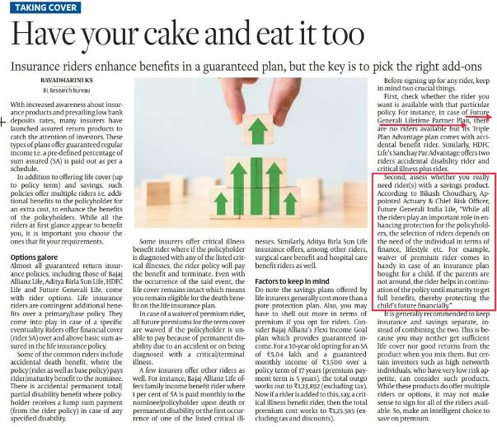

Date | 30th May, 2021
Publication | The Hindu Business Line
Headline | How to choose riders in a guaranteed insurance plan
Link | https://www.thehindubusinessline.com/portfolio/personal-finance/how-to-choose-riders-in-a-guaranteed-insurance-plan/article34678671.ece?utm_campaign=amp_article_share&utm_medium=referral&utm_source=whatsapp.com

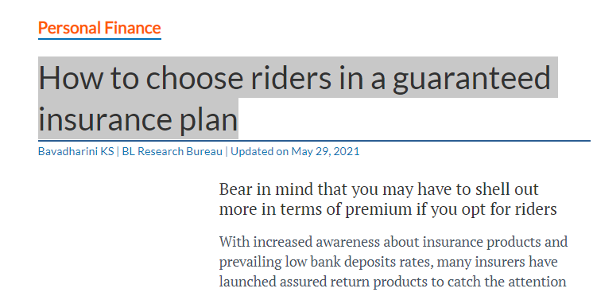

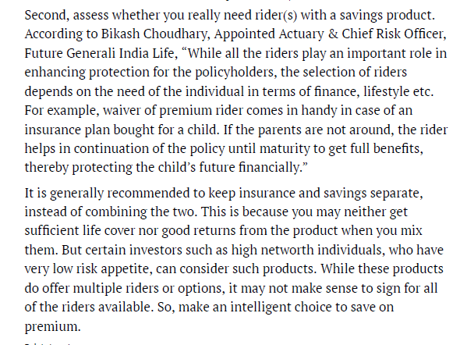

Press Release

Published Date: | 24th May 2021 | Publication: | The Economic Times Wealth – Ahmedabad | Bangalore | Chennai | Hyderabad | Kolkata | Mumbai | New Delhi
Journalist: | Bureau | Page No: | 07



Published Date: | 21st May 2021 | Publication: | Janpath Samachar - Mumbai
Journalist: | Bureau | Page No: | 06

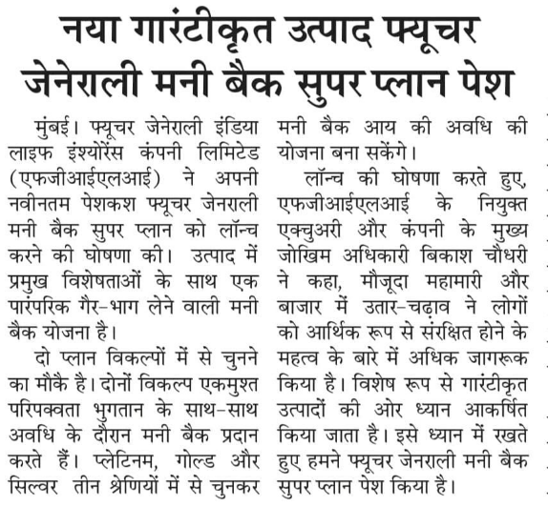

Published Date: | 26th May 2021 | Publication: | Gujarat Mirror: Ahmedabad
Journalist: | Bureau | Page No: | 13

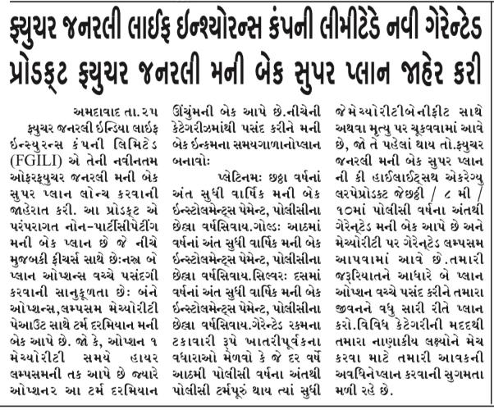

Published Date: | 26th May 2021 | Publication: | Gujarat Samachar: Ahmedabad
Journalist: | Bureau | Page No: | 03

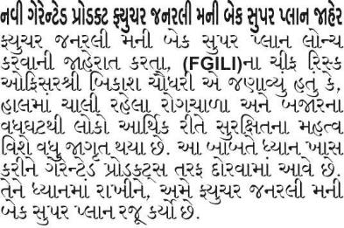

Published Date: | 26th May 2021 | Publication: | Samay Express: Ahmedabad
Journalist: | Bureau | Page No: | 03

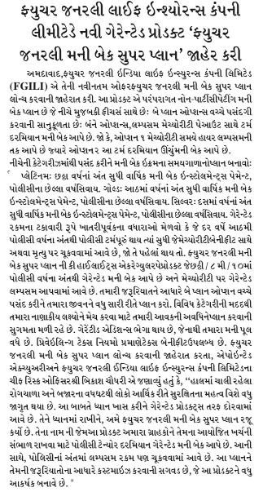

Published Date: | 27th May 2021 | Publication: | Nav Gujarat - Ahmedabad
Journalist: | Bureau | Page No: | 08

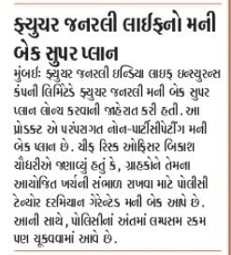

Published Date: | 26th May 2021 | Publication: | Suvarna Bhoomi: Ahmedabad
Journalist: | Bureau | Page No: | 06

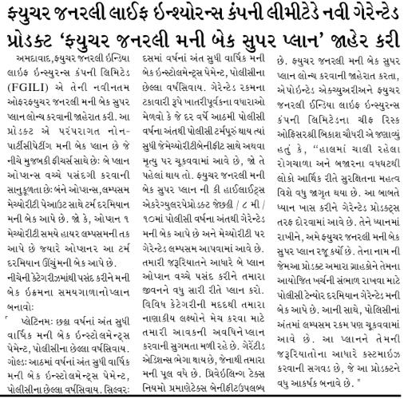
Published Date: | 26th May 2021 | Publication: | Zalawad Samachar: Ahmedabad
Journalist: | Bureau | Page No: | 03
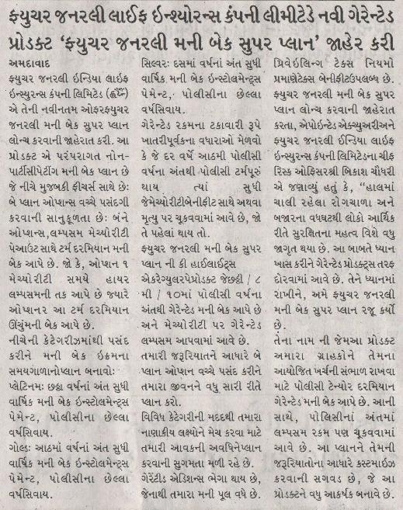

Published Date: | 27th May 2021 | Publication: | Dinakathir : Chennai
Journalist: | Bureau | Page No: | 03

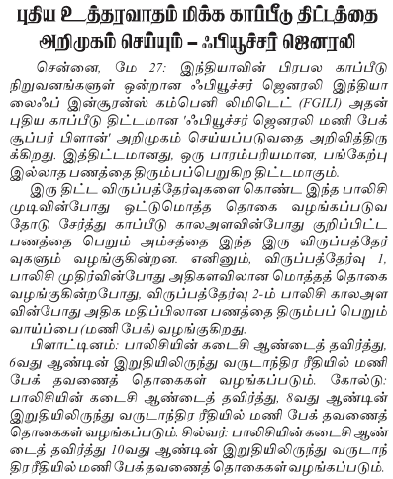

Published Date: | 27th May 2021 | Publication: | Dinakural : Chennai
Journalist: | Bureau | Page No: | 04
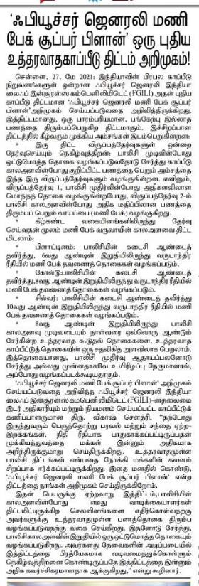
Published Date: | 27th May 2021 | Publication: | Tamil Sundar : Chennai
Journalist: | Bureau | Page No: | 02

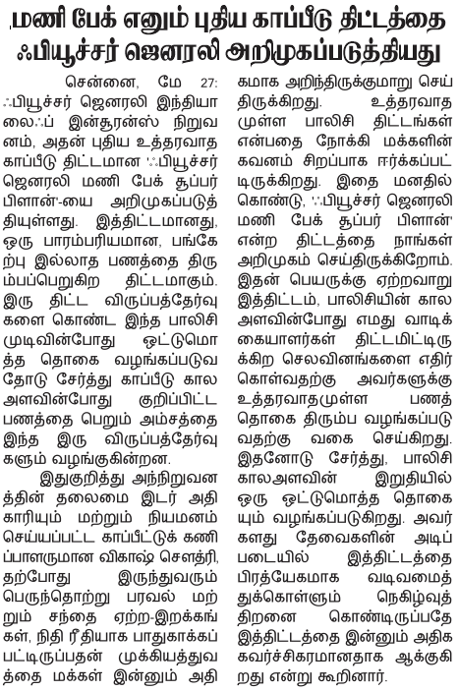

Published Date: | 27th May 2021 | Publication: | Andhra Prabha: Hyderabad
Journalist: | Bureau | Page No: | 05

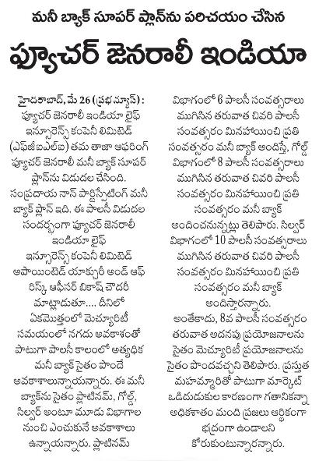

Published Date: | 27th May 2021 | Publication: | Mana Telangana: Hyderabad
Journalist: | Bureau | Page No: | 05

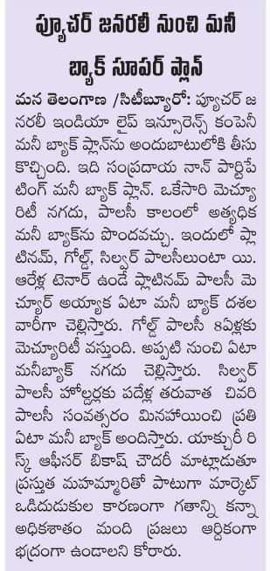

Published Date: | 27th May 2021 | Publication: | Vaartha: Hyderabad
Journalist: | Bureau | Page No: | 05

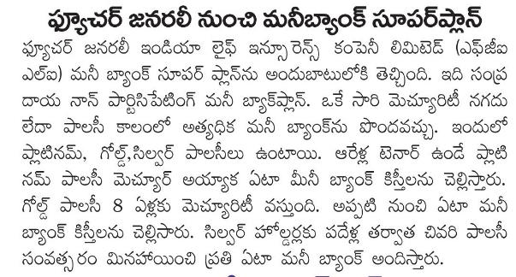

Published Date: | 27th May 2021 | Publication: | Praja Sakti : Hyderabad
Journalist: | Bureau | Page No: | 01

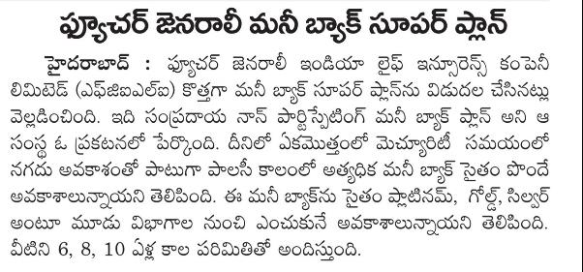

Published Date: | 26th May 2021 | Publication: | Velugu: Hyderabad
Journalist: | Bureau | Page No: | 10

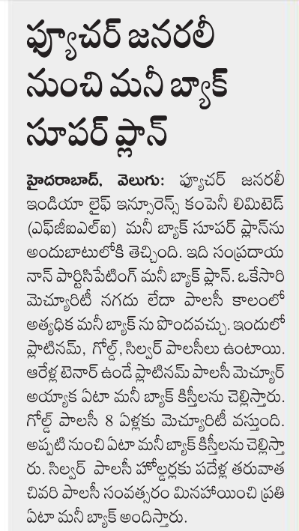

Published Date: | 29th May 2021 | Publication: | Visalaandhra - Hyderabad
Journalist: | Bureau | Page No: | 07

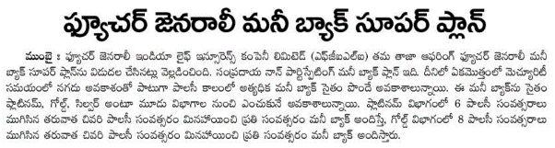

Published Date: | 27th May 2021 | Publication: | Jansandesh: Mumbai | Lucknow
Journalist: | Bureau | Page No: | 13
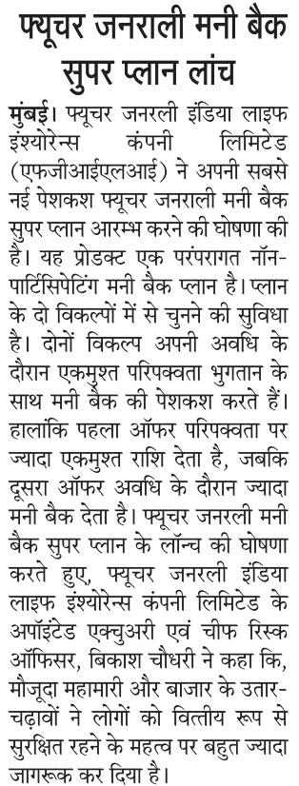
Published Date: | 27th May 2021 | Publication: | Rashtriya Swaroop:Mumbai| Lucknow
Journalist: | Bureau | Page No: | 07

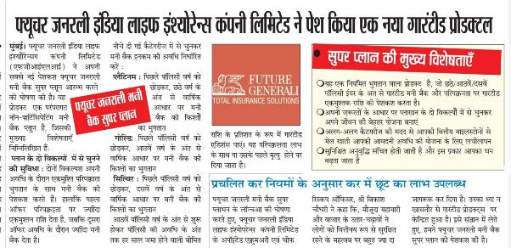

Published Date: | 27th May 2021 | Publication: | Spast Awaaz: Lucknow
Journalist: | Bureau | Page No: | 06

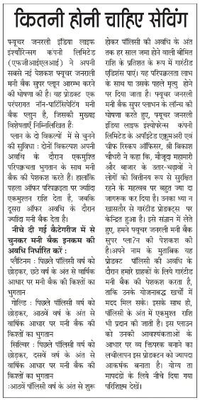

Published Date: | 29th May 2021 | Publication: | Echo of India - Kolkata
Journalist: | Bureau | Page No: | 11



Published Date: | 29th May 2021 | Publication: | Dainik Bhaskar: Delhi
Journalist: | Bureau | Page No: | 11

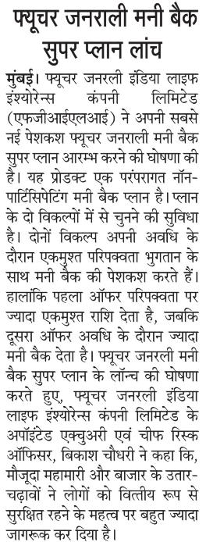

Published Date: | 29th May 2021 | Publication: | Vishwamitra: Kolkata
Journalist: | Bureau | Page No: | 04

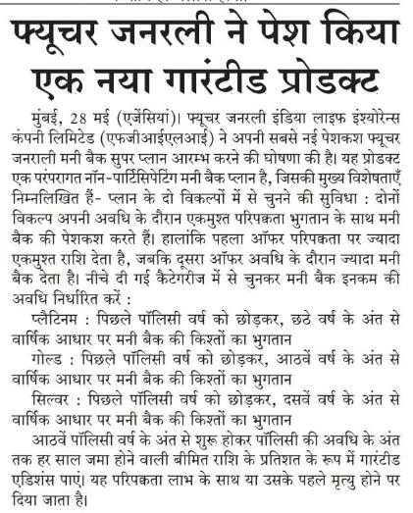

Date | 20 May, 2021
Publication | PTI [Yahoo India]
Headline | Future Generali India Life Insurance launches Cash Back Plan
Link | https://in.finance.yahoo.com/finance/news/business-briefs-145126840.html


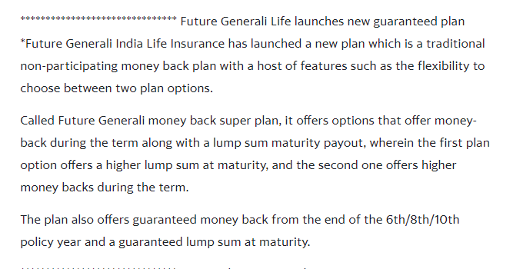

Date | 25 May, 2021
Publication | Telugu Web Dunia
Headline | Future Generali India Life Insurance launches Cash Back Plan
Link | https://telugu.webdunia.com/article/business-news/future-generali-india-life-insurance-company-limited-introduces-a-new-guaranteed-product-future-general-money-back-super-plan-121052500043_1.html

